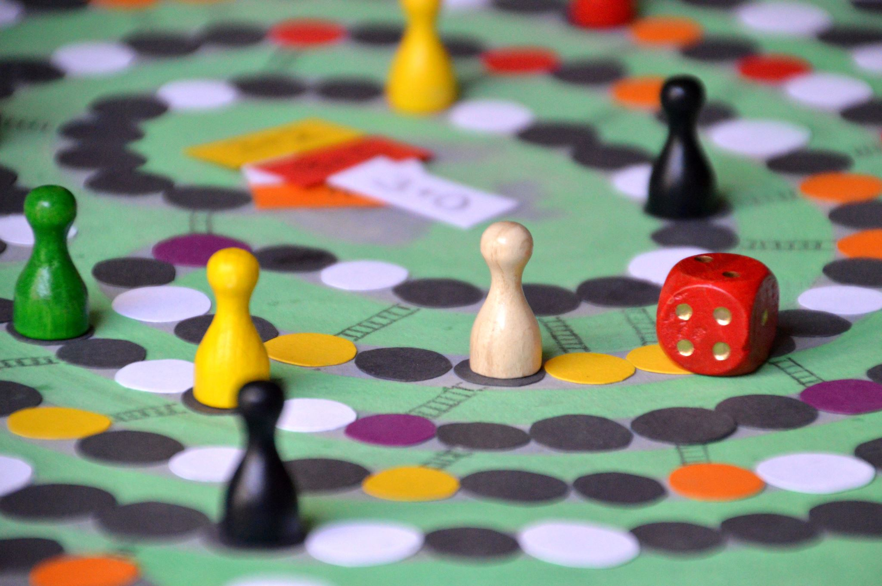

ADKC Games Day

**ADKC Games Day Happy Group 11am – 1pm Monday 6th January**

Do Come along and join in the Fun & laughter playing board and card games, in a friendly environment with your Peer Members, over a cup of tea/coffee and biscuits. You're welcome to feel free to bring your own games and teach someone how to play a new game that they have not played before.

Contact: **Glenda Joseph**

Email: personaldevelopment@adkc.org.uk

The ADKC Centre

Whitstable House

Silchester Road

London

W10 6SB

Speak with Beverley Office Tel: 020 8960 8888