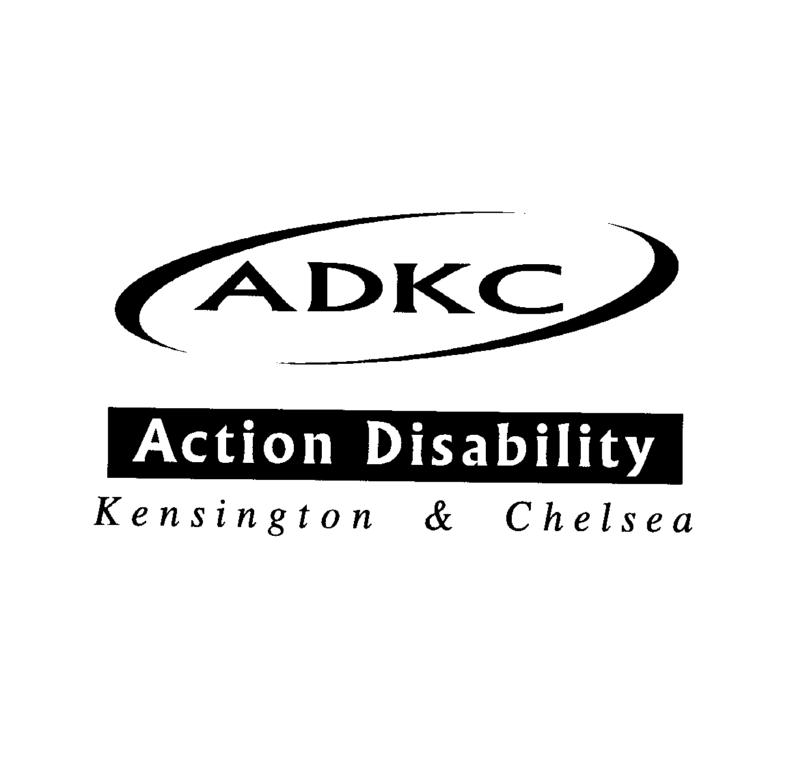
The Chair & Executive Committee of
Action Disability Kensington & Chelsea

Request the pleasure of your company at their

Annual General Meeting

Presentations from ADKC members on our groups and services

On Tuesday 3rd December 2024
4.00pm – 6.00pm
At
Maxilla Social Club
2A Maxilla Way
London W10 6SW
(Bottom of Kingsdown Close)
Tel: 020 8969 2308
And via Zoom:
To confirm your attendance or receive a Zoom invite link please contact Beverley Powell on any of the following,
Email: admin@adkc.org.uk
Phone: 020 8960 8888
Text: 07553 370 074

